|  |  |  |
| --- | --- | --- |
| **Publié le : 30 – 12 - 2024** | **Accepté le : 13 – 10 - 2024** | **Reçu le : 17 -09- 2024** |

**Archaeological ksour, kasbahs, and stores of Touat: Between determining the function and standardizing the terminology in the Saharan domain.**

**Les ksour, kasbahs et greniers archéologiques de Touat : Entre la détermination de la fonction et la terminologie dans le domaine saharien.**

**HADJARI Douriya**[](https://orcid.org/0009-0006-1097-2702)

**University of Abdelhamid Mehri Constantine 2.**

[**douriya.hadjari@univ-constantine2.dz**](mailto:douriya.hadjari@univ-constantine2.dz)

**Abstract:**

This research provides a comprehensive study of the ksour, kasbahs, and granaries in the Touat region, which is notable for its rich array of landmarks characterized by diverse forms, historical origins, military fortifications, and architectural styles. Although numerous studies have been conducted on the Touat area, they remain limited in scope, focusing either on specific architectural types or on particular zones within the region. Therefore, this research aims to clarify the concepts associated with ksour, kasbahs, and granaries, defining their functions within the archaeological and Saharan context. This study offers a detailed analysis of each type of structure, highlighting their roles in the social and economic lives of the region’s inhabitants. Furthermore, it explores the architectural styles unique to each type and underscores their historical and cultural importance. Through this work, we seek to raise awareness of the value of these architectural structures and encourage greater efforts to preserve them.

**Key words**: Touat; ksour; kasbahs; storehouses or granaries.

**Résumé:**

Cette recherche porte sur une étude approfondie des ksour, kasbahs et greniers dans la région de Touat, qui se distinguent par la diversité de ces monuments, et ces fortifications militaires. Bien que plusieurs études aient été menées sur Touat, elles restent limitées à certains types d'architecture, ou liées seulement à une zone particulière. Cette étude vise à clarifier les concepts liés aux ksour, kasbahs et greniers, en définissant leurs fonctions dans le contexte archéologique et saharien. Nous proposerons aussi à travers ce travail une analyse détaillée de chaque type de monument, en soulignant son rôle dans la vie sociale et économique des habitants. De plus, nous aborderons les styles architecturaux propres à chaque type et mettrons en lumière leur importance historique et culturelle, tout en formulant des recommandations pour renforcer la sensibilisation à leur valeur et encourager les efforts de conservation.

**Mots clefs**: **Touat; ksours; kasbahs; greniers.**

**Mail de correspondance: Hadjari, Douriya. h.doria@hotmail.fr**

**Introduction:**

The Touat region in the Algerian desert is one of the world’s richest areas in terms of its archaeological architectural structures that reflect ancient and deeply rooted social and economic traditions. This region is rich in a diverse range of Ksour, kasbahs, and storehouses that reflect the nature of the desert life and its complexities. These structures have always been considered a comprehensive combination of defensive, residential, and economic functions as they provide protection, storage for goods, and housing for the various segments of society.

In this research, we will provide a comprehensive analysis of these architectural structures by highlighting their concepts, functions, social and economic importance, as well as their most important architectural styles. We will also clarify the architectural and structural differences between various types of buildings. In this context, we will try to determine the mutual relationship between Ksour, kasbahs, and storehouses and how they impact the social structure and class distribution of the Touat community. Hence, this article seeks to offer a deeper understanding of the different architectural styles of these landmarks that are widespread in the Touat region.

In order to study this subject, a range of historical sources and previous studies were consulted, which enabled us to understand the temporal and cultural context in which these buildings emerged. The accounts of historians and travelers, such as *Ibn Baṭṭūta*, *Ibn Hawqal*, and *Ibn* *Khaldūn*, were referenced to highlight the early explorations conducted in the region. We have also reviewed a range of previous research and studies that played a crucial role in refining concepts and identifying architectural patterns. In this context, Echallier’s study, *"Villages désertés et structures agraires anciennes du Touat-Gourara (Sahara Algérien)"*, is considered one of the most important works in the field of desert ksour architecture, particularly from an archaeological perspective. Equally important are the works of Bisson (*"Le Gourara: Etude de géographie humaine"*) and Rey (*"Greniers domestiques et greniers fortifiés au Sahara: Le cas du Gourara"*) in the field of kasbahs and desert storage architecture. Thus, these studies have expanded knowledge by analyzing and discussing various scientific approaches.

To address the different aspects of the research, two main methodologies were employed: the historical method and the analytical method. The historical method was used to narrate the various events and trace the historical facts that contributed to the construction of these landmarks, allowing us to understand the key developments and the temporal and cultural context in which these buildings arose. This method also sheds light on their social and economic role in the region. The analytical method, on the other hand, enabled us to break down the architectural elements that characterize these ksours, kasbahs, and storage facilities, study their architectural styles, in addition to identifying their most significant features and characteristics that make them an important part of the architectural heritage of Touat. Accordingly, we aim to provide a deeper understanding of these historical buildings and present a historical and cultural vision that contributes to preserving this rich heritage for future generations.

1. **The Geographical Location of Touat and its Ksour:**

The Touat region is located in the southwest of Algeria. It played a strategic role in the Islamic Maghreb during the 14th century AD, especially, through its trade routes that connect the north (such as Hūnyne in Tlemcen) and the south (Timbuktu in Sudan). It consists of three large regions: Gourara in the north, central Touat or Tsouat, and Tidkelt in the south. (Voguet, 2018)

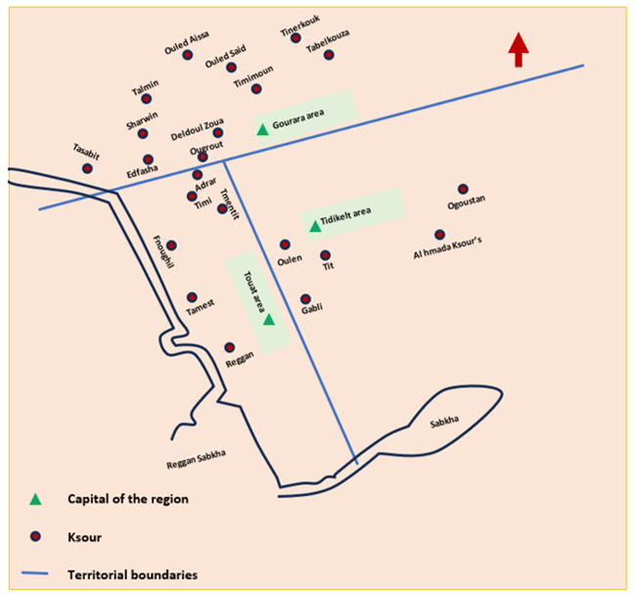

**Face n° 1: Touat region and some of its Ksours**

**Source: Author**

* 1. **The** **Gourara Region (Tigourarine):**

This region is as important as Touat, but it is less populated, less urbanized and less productive. Its center is the city of Timimoun. Its Ksour extend in the form of a circle with a diameter of 80 km, centered in Timimoun. Its furthest Ksour are Tbelkouza in the northeast and Oufrane in the south (Bisson, 1957: 93-94)

According to the classification of Faradj Mahmoud Faradj its Ksour are represented in the following:

|  |  |
| --- | --- |
| Their components | The Ksour |
| Taghtast, Al-Dabbaa Zawīya, Terzīra, ʿīn Ham, Fatset, Wūedʿā, Sidi Mansour, Talqmin Tamzlane, Anqal, Ibn ʿīssa, Tūnezra, Haiha, Yak.  Tabelkūza is the center of the Tinrkūk province, which is affiliated with the Gourara region. It extends over a distance of 50 km east of the Saoura Valley and south of the Great Western Erg. | **Ksour Tbelkuza (Tbelkūzra):** they are composed of 13 Ksour. |
| Taghzi, Nʾāma, ūled ʾssa, The Eastern Ajder, The Western Ajder, Touat. | **Ksour Talmin:** they include 6 Ksour located between Tabelkouza and Cherouine. |
| Major and minor Tfawet | **Ksour Cherwin:** they contain two Zawiyas. |
| ṭalmin Al-Hadj, Dalman, Bab Yad, Samouta, Mourad, Maghmoura, Pharaoh, Ibn Issa, Badriyan, Yafza, Al-Kaf. | **Ksour Gourara (Krara):** they contain 11 Ksour. |
| Bdara, Lazura, Ouled ʾabdali, ūled Haroun, Kali, Safhan, Al Ahmar, Kantoura, Aghlad. | **Ksour Ouled Said:** they include 10 Ksour. |
| Atlet, Zaqour, Touria, Aalmlal, Waamni, Aghiath, Masin, Ouled El Hadj, Tizkent (Taroukent), El Koubra, Tadmait, ūled El Mahdi, ūled Yahya, Kasbat El Qaid, ūledIbrahim, Talan Ham, Ouled Noah, Al-Zawiya, Beni Mahlal, Lichta, Ighnath, Beni Mlouk, ūled ʿllal (ʿAla), Tawurist, Tamana, Oujda and Timimoun. It is located on the road leading to El Menia and Ghardaia. Its style is similar to that of the cities of Sudan. It has a large wall with five gates. It is divided in the inside into six neighborhoods. (Faradj Mahmoud, p. 23) | **Timimoun Province (26 Ksour)** |
| Boukma, Al-Shaef, Aaya, Al-Zawiya, Aqiour, Aaboud | **Ksour ūkrout (Ougrout) (**6 Ksour) |
| Ibn ʿbed (Abed), Tiraghmine, Kasr Al-Hadj, Tala, Sidi Abdullah Zawiya, Tanqaleen. | **Ksour Al-Khanafisa** (6 Ksour) located in the southermost of Gourara. |
| Ouled Abd al-Samad (Bouamama lived in their land), Toki, Al-Baraka, Al-Harban (al-Hadban), Al-Mansur, uled ʿbbou (Aab), Ourir, Aqbur, Al-Sahla, umran (ufrane), uled Mahmoud, and Kabrtan. | **Ksour Deldoul:** they arelocated in the south of Gourara region and include 12 Ksour. |
| Ouled Rached, Ouled ʿli, Al-Qarasha, Al-Sahla, Al-Matarfa (Al-Mtarfa). | **Ksour Daghamcha:** they are located in the south of Gourara region and include 5 Ksour. |
| ʿaryan Al Rass, Barnkan (Ibertkan), Hamadi, Amour (ʿamour), Al-ʿayad, uedjlan, Lamieez, Oualhila (Al-Habla), Al-Sabaʿ, Al-Karara. | **Ksour Tsabit (Tebit):** they arealso located in the south of Gourara region, which is the region that Al-Ayashi visited while passing through the region on his way to Al-Hijaz, and it includes 10 Ksour |

**Tableau n° 1:** **List of Ksour in the Gourara region**

**Source :** (Faraj, 1977 :141-139)

* 1. **Central Touat Region (Tissuwat):**

Thanks to its central location; economic prosperity; and urban development, this region is considered one of the most important regions. It is situated between the ends of the upper Gourara hill, which forms the eastern edge of Oued Messaoud and its opposite edge known as the Western Erg. Thus, it extends from the heights of Kasr Bouda to Reggane. Its Ksour include the following:

|  |  |
| --- | --- |
| Al-Qasiba, Tbelkou, ulad Yaʿch, Al-Amarin, Abar, Ouled Najl, Ben Dhraa, Zawiyat Ibn Bel (Yel), Ouedrar, Beni Ouazel, Ghram Ali, Al-Zawiya, Al-Mansour. | Ksour Buda: It is the first province of Touat in the north and includes 13 Ksour. |
| Tlilan (Tnilan), Wina (Wayna), Mimoun, Mlouka, Bouzat, Kisan, Barbaa Sidi El-Mehdi, Barbaa Sidi Naqi (Taqi), Barbaa Ouled Sidi Ahmed, Barbaa Almorabitin, Zawiyat Kerzaz, Barbaa Aba Azour, Aqdim, Ark Karara, Adghagh, Ouled Naqlal (Anqal), Ouled Wchen (Ouchen), Ouled Ali, Ouled Ahmar, Bardane, uled Ibrahim, Beni Tamer, Al-Mansuriya, Aqbour, Ouled Bouhafs, Mahdia, uled Amour, Ouled ʿissa, Ouled Arsa, Ba Abdullah, Zawiyat Sidi Bakri. | **Ksour Timi:** It is considered the heart of the Touat region and includes 32 Ksour. |
| Kasbah of Ouled El Hadj El Mamoun, Amkir, Belhaj. | **Ksour Tamantit**: It is located 12 km south of Adrar and was the center of the Touat region before the 18th century AD. It includes 3 Ksour. |
| Touki, El Kasr El Kebir, Betkor (Benkor), Bemnas. | **Ksour Boufara (Boufady):** It is located southwest of Tamantit and includes 4 Ksour. |
| Tasfa, ʿabani, Al-Aoushia (Al-Alouchia), Wedgha, Benhami, Azzi (Anri), Al-Mansour, Makra, Kasbah of uled Moulay Al-Hassan, ulad Berrechid, Ksibat Al-Ahrar, Kasbah of Ouled Moulay Fares, Zawiya of uled Sidi Abdelkader, Sidi Youssef. | **Ksour Finghil:** It is located south of Tamantit and includes 14 Ksour. |
| Baʿmer, uled Bou Hay El-Fuqaniya, uled Bou Hay El-Souflaniya, Al-Jdid, uled ʿAntar, Tmalt, Al-Ahmar, Kis, Tamsakht (Tmasakht), Aghbal, Adrar, Titif | **Ksour Tamest (Temset):** It is located in the middle of the central region of Touat and includes 12 Ksour. |
| Ghazmaine, Touririn (Touriran), Zakel (Zaghlou), El Bayadh (Al-Abyadh), uled El Hadj El Borj, Zawiyat Kenta, Teberkant, Tahfift (Takhfift), El Mnaser, Tazelt (Tazouelt), Zawiyat Sidi Ben Abdelkrim, Boʿali, Tetouan El Charfaa, Mekir, El Mahfoudh, Admar (Admar). | **Ksour Ouled Yasdi Ham Ben El Haj:** Also located in the middle of the central region of Touat, and includes 10 Ksour. |
| Aʿr Mellal, Azwa, Buanki. | **Ksour Rassami (Sali):** One of the Ksourof the central region of Touat and includes 3 Ksour. |
| Zawiyat Bilal, Tadmayin, Al-Khalqi, Tetuwan Al-Khras, Tilwine (Tlouline), Tabnourt, Ouled Bah, Anzklouf, Tamednine, Abrich, Zawiyat Mahchef (Lahchef). | **Ksour Zejmi (Atejmir/Anzejmir):** itincludes 11 Ksour. |
| Ait Messoud, Tanoulfat 1, Tanoulfat 2, Taʿrabt, Intahent, Tuwrirt. | **Ksour Reqan (Reggane):** it is located 170 km south of Adrar and includes 6 Ksour. |

**Tableau n° 2:** **List of Ksour in the central Touat region**

**Source:** (Faraj, 1977 :142-143)

* 1. **Tediklet region**:

The name in Berber means "palm of the hand." It is located east of Reggane, between the southern slope of the Tademait hill and Oued Djarit to the north. Its Ksour are distributed over a flat area with few hills. Its center is Aoulef. It must be pointed out that despite the abundance of its groundwater, its inhabitants are more interested in trade and camel herding than in agriculture. This is because the region is considered a meeting point and a gathering place for the caravans crossing the desert. This is in addition to using camels for transporting goods and travelers, as well as for renting. (Faraj, 1977 :23-24)**.** Its Ksour are distributed from west to east as follows:

|  |  |
| --- | --- |
| Ksour ʿarab Tedikelt (uwlef): it includes 13 Ksour | Tamlikten (Tamkten), Kasbat Sidi Malouk, Zawiyat Moulay Hiba, Kasbat Moulay Dhaher (Taher), Kasbah Moulay ʿAbdallah, Ulf, Al Churafa (Churfa), Taqrf, Jadid, KasbaT Habadat, KasbaT Bilal (Ablal), Zawiyat Haitoun (Hainoun), Kasbat Omanat (Kasbat Amanat), Kasbat Ouled Al-Chail. |
| Ksour uebli (Aqbali): It is located between Reggane and Ain Salah and includes 4 Ksour. | Sahil, Al-Kechach (Akchach), Al Mansour, Kasbat Sidi Al-Abed. |
| Kasr Tit | It is located between Reggane and Ain Salah and is also known as Kasbat Al churafa. |
| Ksour Yengher/Ingher (ʿAin Ghar): it is located between Tit and Ain Salah and includes 4 Ksour. | Kasbat Ouled Djeljoul (Helloul), Kasbat Ouled Hadka, El Kohl, Miliana. |
| Kasr Al-Hamada: it is located between Ain Ghar and Ain Salah and includes 2 Ksour. | They are Al-Zeghamra and Loukert. |
| Ksour Ain Salah: it is considered the center of the Tedikelt region. It is located in the east of the Touat region and includes 11 Ksour. | uled Mokhtar, Kasr Ouled Ab Joud, Ouled Belqacem, Ouled Belhaj, Zawiyat al-Ma al-Baraka, Hassi El Hjar, Aquestan, Al-Sahla, Miliana, Mfazat al-Zawa, Matroun, Bulbul. (Note that the distance between Matroun Palace and Bulbul requires about 3 hours) |

**Tableau n° 3: List of Ksour in the Tediklet region**

**Source :** (Faraj, 1977 :144-145)

1. **The social classes of Touat:**

The social stratification in Touat played an important role in determining the role and function of architecture in these areas. These social classes are represented as follows:

* 1. **The nobles and Gentlefolks:**

This class consists of individuals who trace their lineage to the Prophet Muhammad (peace be upon him) through his daughter Fatima al-Zahra. Most of them came from Morocco (Faraj, 1977 :13) specifically from Tafilalet, Sijilmassa in the mid-15th century AD (Vogue,2018). They were highly respected in Touat as members of the Prophet's family, thus, they contributed to resolving disputes within the community. They were the owners of gardens and orchards as they were seen as protectors of the religion. These are in addition toAlmoravids who are descended from the first companions and enjoy a good social status. Their presence is accompanied by the construction of zawiyas, whether it is related to the Arab Almoravids or the Zenata Berbers.

* 1. **The common people:**

They are also known as "the free people." This class includes both Arabs and Berbers. The majority of this group worked in trade and owned slaves and gardens (Bisson, 1957: 63-64).

* 1. **Blacks :**

This category includes the Haratin class (Harathanians). They are a group of freemen and slaves who performed all the laborious tasks that the freemen typically avoided. The slave category was at the bottom of the social hierarchy and was responsible for various strenuous tasks such as digging water wells, agriculture, and herding (Faraj, 1977 :13).

1. **History of research:**

The regions of Gourara and Touat remained largely unknown for a long period of time. This is particularly true because most Arab geographers who visited and described the regions of North Africa and some desert areas on the southern desert borders provided only limited information about these areas. Examples of these are Herodotus, Pliny, and Ptolemy books (Echallier(JC), 1972: 17). Among the Arab travellers of the 10th century AD is *Ibn Hawqal*, who has only mentioned the Berber tribes in Morocco and noted their large numbers and widespread presence in the wilderness and deserts (Ibn Hawqal, *Al arḍ*: 100).

Moreover, *Ibn Baṭṭuṭa*, who arrived at the Budda oases in Touat after ʿid al-Fitr, has provided a brief description of some areas of Touat, such as Tessabit and Budda. However, he did not mention detailed information about their architecture (Ibn Battūta, *Tūhfat*: 279).

Ibn Battuta was followed by the Genoese traveller Antonio Malfante who visited Touat in 1447 and was able to describe these desert areas in the latter half of the 15th century AD (Antonio Malfante et Mercante Genovese, 1868: 442).

Additionally, in the 15th century the historian and geographer *Ibn Khaldun* has mentioned the Ksour of Touat and Gourara in several places when he referred to the tribes of Arab al-maqil. He mentioned all of Touat, Budda, Tmantit, Tessabit, and Tikourarines, which are known as numerous Ksour with palm trees and rivers and that most of their inhabitants were Zenata (Ibn Khaldūn, *Al ʿibar*: 59). He also noted that the number of Tikourarine’s Ksour reached three hundred or more (Ibn Khaldūn, *Al ʿibar*: 102), but, the information regarding the architecture of these Ksour remains inaccurate. According to Echallier, much of the information provided by *Ibn Khaldun* indicates that he was unfamiliar with the region and lacked detailed knowledge about it (Echallier(JC), 1972: 11).

The traveler Leo Africanus, known as *Hasan al-Wazzan*, mentioned both Tessabit and Tikourarine. He referred to Tessabit as "Tasabine" and described it as being nine days away from Sijilmassa, inhabited only by Berbers living in four Ksour and several hamlets and its inhabitants were poor (Kārbākhāl, *Ifrīqyā*: 162).

As for Tikourarine, he referred to it as "Tikourairine." He described it as being about 40 fārsākh away from Tessabit, its people lived in fifty scattered Ksour and over a hundred hamlets amidst palm trees and its inhabitants were wealthy (Kārbākhāl, *Ifrīqyā*: 163).

It must be also pointed out that the first European explorations have occurred after the regions of Touat and Tedikelt came under the French rule, which was a result of military operations for penetrating the desert areas. For example, the work of the officer and translator George Martin in 1904 involved collecting a range of manuscripts about the history of the region and providing important information on the architecture and development of the Ksour. He divided the history of the area into four phases (the Getulian period, the Jewish period, the Zenata period, then the Arab period.) His works were followed by the work of John Bisson and Echallier, who provided a comprehensive classification of the Ksour in the Touat region, each with different criteria (Although these are not the only works done on the region, they are among the most significant ones).

1. **The architecture of Al-Ksour:**
   1. **The concept of Al- Kasr:**

Martin considers the Ksour to be a single village or a group of villages. His definition of Al-Ksar focuses on the class and ethnic division of the Touat society. According to Martin, the place of residence varies according to the social class; the important class of the society lives in the kasbahs, while the common people reside in the Ksar. When a tribe gains prominence in society, it builds a kasbah, whether the tribe is Arab or Berber. If the Ksar was established by a Berber tribe, it would be used by all social classes and the kasbah would be dedicated solely to storage. However, if the tribe is Arab, the kasbah serves as a residential space and is privately owned knowing that the Ksour are larger than the kasbahs. As for the defensive system of the Ksour, most of them contain elements that enhance their strength and resistance, except for some, such as Kasr Tedikelt, which lacks a defensive system (Martin, 1908: 7-8.).

Bisson agrees with Martin that the Ksar is a fortified and miniature village and adds more detailed information regarding the internal distribution of the Ksour. He mentions that a Ksar consists of a group of adjacent dwellings and narrow streets that vary depending on the nature of the site. If the Ksar is situated on a plateau or a hill, the roads would be winding, while they would be straight and intersecting if the Ksar is built on flat areas (such as reg or hamada). Bisson also notes that each Ksar always belongs to a specific ethnic group and the distance between Ksour ranges from tens to hundreds of kilometers. Add to this, each Ksar has its own kasbah and some of them often share the same oasis (Bisson, 1957: 157). Moreover, the Ksar contains a wall that includes one or two watchtowers and an entrance known as the "mouth of the Ksar" (Bisson, 1957: 160).

* 1. **Types of Ksour in the Touat region:**

Martin is considered one of the first researchers to classify the Ksour of Touat. He based his study on the division of the Ksour according to the time period and the ethnic differences of the tribes that inhabited them. Hence, Martin has identified the main types of Ksour as follows:

* **Ksour of the Gietul period**: These include the Ksour built in or before 100 AD and are known as "Taourirt," such as Ksar Talboua, Reggane, Cherouine, and Deldoul (Martin, 1908: 33).
* **Ksour of the Jewish**: they extend from 100 to 600 AD and are characterized by their circular shape and proximity to water sources, such as Ksar Tazoult Al-balia and Kasr Makid (Martin, 1908: 46-47).
* **Ksour Zenati**: They date from 600 to 1050 AD. These Ksour are marked by Berber names reflecting the Zenati presence in the region. The Zenata tribes have also brought some Kharijite influences that faded over time (Martin, 1908: 59).
* **Ksour of the Arab period**: they extend from 1050 to 1120 AD. The first Arab tribes began to migrate towards the desert oases after the fall of the Ubaid state in the latter half of the 10th century AD. These tribes have established many Ksour, the areas in which the "Fouqarat" system has appeared for the first time (Martin,1908: 61-62). This is followed by the **Ksour of the Hilalian period** from 1120 to 1230 AD, during which new Ksour were built in addition to the old ones, such as the Ksour of Tbalkuda or Tbalkoza in Zenati (Martin, 1908: 80-81).

However, many researchers who studied the desert Ksour after Martin, such as Echalier and Capot Rey, argue that Martin's study did not rely on archaeological data, which led him to several incorrect conclusions. For instance, he mistakenly considered the circular shape of the Ksour to be more recent than the rectangular shape and categorized the types of Ksour based on the ethnic affiliation (Berber/Arab).

Twenty years after Martin's study of the Ksour of Touat, Echalier's study emerged as an important reference for researchers on the history and architecture of the desert Ksour. Echalier made significant contributions to understanding this type of architecture as he did not only focus on the archaeological aspect but also analyzed different types of Ksour in a precise systematic manner. He developed a classification system that is based on various criteria such as the geographical location, the divisions of the internal space, the general shape of the Ksour, in addition to the history and the ethnic diversity of the communities that inhabited these Ksour. This researcher’s study can be summarized into six main types, including primary and secondary ones (Echallier(JC), 1972: 37-57-59).

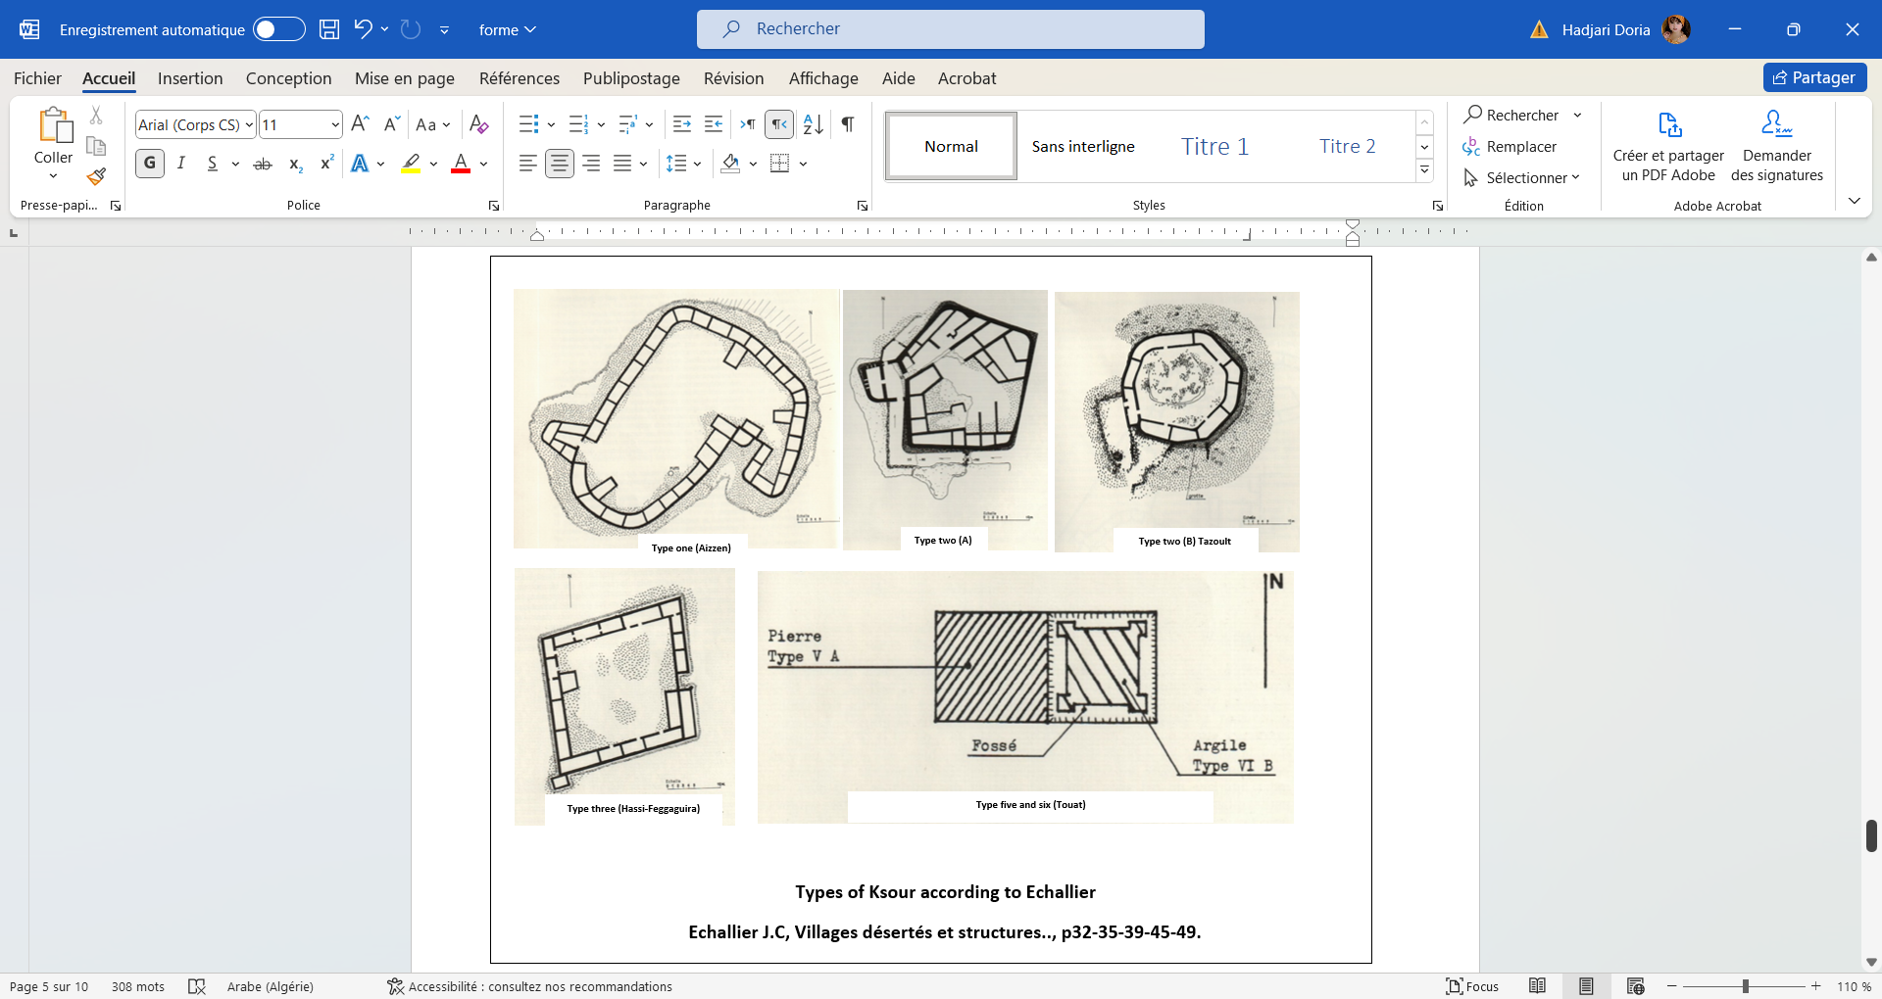**The First and second types**: They are subdivided into two groups (A and B). Their models include Ksar Tamsakh and Takhfif.

**Face n° 2: Types of Ksour according to Echalier**

**Source: Echallier J.C, Villages désertés et…, p 32-35-45-49**

**The third and fourth types**: They do not have secondary groups. Their models include Ksar Ouled Yakoub.

**The fifth and sixth types**: They are also divided into two groups (A and B) and their models include Kasr Ali Moussa and Ksar Ouled Mohammed and Ouled Daoud.

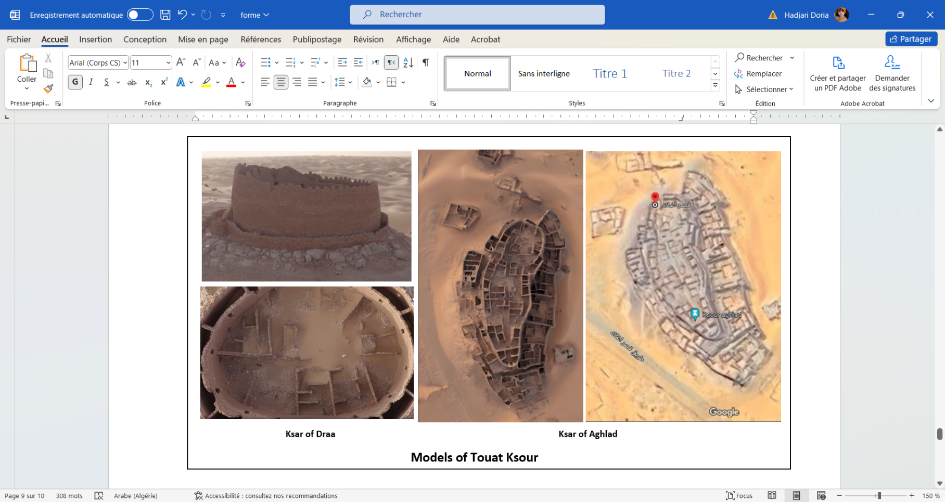Unlike Bison, Echallier considered that rectangular plans are more recent than circular ones. He argues that circular plans require less intellectual skill compared to rectangular plans, which demand more advanced engineering skills. Echallier also believes that the sixth rectangular type represents an influence from the East with the same mud-brick construction techniques that are used in Morocco. However, it is important to note that this rule cannot be generalized to all the Ksour as many of them, such as those dating back to the Islamic period, have taken different forms imposed by the nature of the site.

**Face n° 3: Models of Touat Ksour**

**Source: Google maps**

Despite the accuracy and depth of Echallier's study, his typology of the Ksour focused on basic architectural elements and did not give significant attention to the internal components of the Ksour, such as the kasbahs and stores. Therefore, further studies and research are needed to combine the criteria of the architectural elements and the internal distribution of Al-ksar across all the regions of Touat (El Gourara, Tedikelt, Touat). This is in addition to supporting them with archaeological excavations to provide a deeper and more comprehensive understanding of the architecture of the desert Ksour in Touat and the Algerian Sahara in general.

1. **The architecture and design of the kasbahs:**
   1. **Concept of the kasbah:**

Martin noted that the general style of kasbahs is characterized by a square or rectangular shape, in addition to square towers connected by a high wall or rampart that consists of two or three floors. This later is made of dried and baked bricks and often surrounded by a moat on the outside. Martin also believes that the Ksour inhabited by Berber tribes combine all the social classes of the tribe, from the wealthiest to the poorest members. It is worth mentioning that in these types of Ksour, the kasbah is not used for residential purposes but serves as a store in general and a shelter during enemy attacks, which makes it a public facility. Whereas, in the Ksour that are inhabited by Arabs, the kasbah is a private (estate) establishment used as a residence by one or more families of the ruling or royal class (the wealthy), in addition to some farmers and merchants that work for them (Martin ,1908: 8).

Capot Rey defines the kasbahs as fortified buildings situated on high rocky plateaus containing a range of stores. Hence, they are also known as fortified granaries. He mentions that many inhabitants of El Gourara refer to these fortified stores or kasbahs as "Ksour," but they actually mean fortified stores similar to those found in the Tunisian Ksour that include "rooms." (Rey, 1956: 142-143). This type of kasbah was named the "granary kasbah" as it served as a secure place for storing agricultural products, such as those built along the Sabkha of Timmimoun in El Gourara. It should be noted that most of the Ksour contain kasbahs, which have various facilities both inside and outside, such as towers, mosques, wells, and most importantly, storage areas.

There is another type of kasbah whose definition differs from the previous one because it differs architecturally in terms of its internal arrangement and serves as a residence for wealthy families in the region (Rey, 1956: 143-144). This type of Kasbahs is similar to the ones studied by Meunié in southern Morocco, particularly in the Draâ region, where fortified villages rather than fortified storages, were prevalent (Meunié, 1951: 147). Therefore, this type can be referred to as the "residential kasbah."

In El Gourara region, the kasbah plays two main roles: military and commercial. While, outside of El Gourara (in Touat) the role of the kasbah varies depending on the family that inhabit it (whether poor or rich) (Rey, 1956: 150).

Among the observed differences between Bisson's and Capot Rey's studies is that Bisson focuses more on the distribution of kasbahs in relation to the Kasr rather than on their function. He focused his study on the kasbahs designated for storage and noted that the kasbah, in the Zenati Berber context, is referred to as "*Aghrem*." This reminds us of the Tighremt found in the southern regions of Morrocco, which are fortresses or castles with a rectangular layout that include rooms designated for storage (See: (Terrasse, 1938: 48-52). Thus, they are similar to the kasbahs of Touat, which contain a number of stores for general provisions and serve as refuges during conflicts, which explains the many loopholes in their walls.

Bisson also mentions that kasbahs are characterized by their overall plan that varies depending on the topography of the area. When built on hills, their shape is either circular or oval (such as Lichta and Beni Mahlal)), whereas when built on a plateau, their shape is rectangular. (such as in Beni Melouk, Kali, Qalu, Tbalkoza) (Bisson, 1957: 150). During times of peace, kasbahs are accessed using a wooden beam shaped like a bridge. To further fortify the kasbah, it was surrounded by a moat and a well is usually constructed inside it to help the family or tribe withstand for as long as possible. The kasbah also contains several other defensive features such as watchtowers, loopholes, and shooting openings. The most important internal architectural components of the kasbah are the Quranic school and the mosque (such as Qalo), which sometimes made the kasbah similar to El Ksar (Bisson, 1957: 152-153).

It is worth noting that the tribes did not abandon the kasbahs even in times of peace in the region. This is due to their numerous benefits, especially in the Oasis of Erg as the area's dwellings are small and often surrounded by barns that are threatened by fires, which makes storage impossible. Moreover, other regions must always be protected from termites, which penetrate wood and clay. Therefore, kasbahs are often built on rocks. The kasbah was considered a center for trade exchanges for caravans and a center of attraction and gathering for a group of low-lying Ksour that extend over several kilometers such as Fatis. Among the reasons that made the tribes cling to the kasbahs is that the foreign owner of El Ksar has the right to possess a store within the kasbah in which he does not reside. Thus, he can retain or sell it to a trading caravan without needing to transport the goods to the Ksar in which he resides. This has kept the kasbahs active despite the abandonment of the houses adjacent to them (Bisson, 1957 : 152-153).

* 1. **Types of kasbahs:**

The types of kasbahs varied based on the criteria used by researchers. When arranging their studies historically, it is observed that Martin, one of the earliest researchers in the region, has classified the kasbahs into two main types based on the ethnic origins:

**Granary kasbahs:** They are found only in the Berber Ksour. These kasbahs are inhabited by various social classes from the nobility to the lowest social class of the Haratin and blacks. These kasbahs serve as public establishments used for storage and shelter when needed.

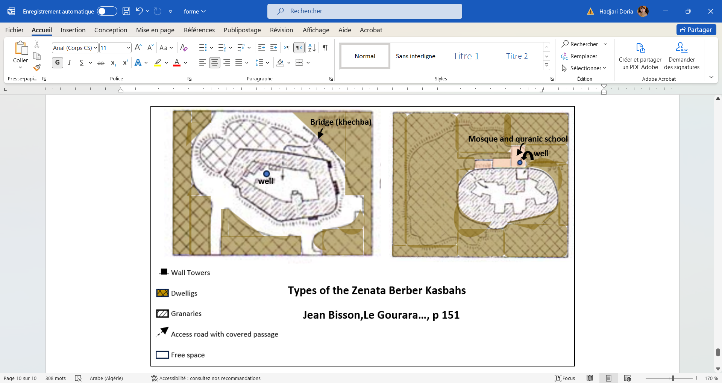

**Face n° 4: Types of the Zenata Berber kasbah**

**Source : Jean Bisson, Le Gourara…, p151.**

* **Residential kasbahs:** They are found in the Arab Ksour. These kasbahs are private properties of the ruling and prominent class within the ksar. This view is supported by Karl Suter, even though his article appeared about fifty years after Bisson's study. He provided a precise description of this type of kasbahs. He describes them as buildings inhabited by Arab tribes, typically square or rectangular in shape, fortified by an outer wall with a height of 6 to 7 meters and thickness of 1 to 2 meters that narrows as it moves upwards. The length of its side ranges from 100 to 300 meters and each corner of it contains a square tower with a truncated pyramid shape. In the important Ksour, the wall is reinforced with additional towers in the middle of each wall of the Kasbah. The height of these towers ranges from 8 to 10 meters, each of them containing two rows of loopholes. The wall is surrounded by a moat that is locally called “*Ahfir”* with a depth ranging from 4 to 6 meters (Suter, 1953: 463-464). Nevertheless, this view can only be applied to the ksour of Touat and Tedikelt, which are inhabited by Arab ruling families, in contrast to the Ksour of El Gourara that include kasbahs with different ethnic origins. An example of this is the Arabic kasbah of Tbalkoza, which resembles the Zenati kasbah of Beni Melouk and the Arab Ksour of Fatis that closely resemble the Berber Kasr of guellou. This suggests that during Martin’s period there were Arab kasbahs of the type that he described, especially in the northern part of the Sebkha where many Arab tribes settled. It is noteworthy that all the kasbahs that were used as fortresses and not as stores had disappeared by the time of Martin (Bisson, 1957: 156).

If the entire region of El Gourara was Berber and the Touat region was Arab, we might have supported Martin’s view. However, Martin’s view contradicts with the fact that a significant number of the Ksour of El Gourara, in addition to Kasr Tinerkouk, are Arab and that the kasbahs of these Ksour such as Tahantas, Tbalkoza and Fatis are all used for storage rather than royal residences. If granary kasbahs were exclusive to Berber tribes, we would also find them among other Berber tribes like Beni Mzab or the Tuareg. Yet, it is known that the tribes of Beni Mzab, for example, do not have storage facilities, thus, they store their savings in one of the rooms of their homes or in the mosque in cases of danger (Rey, 1956: 151).

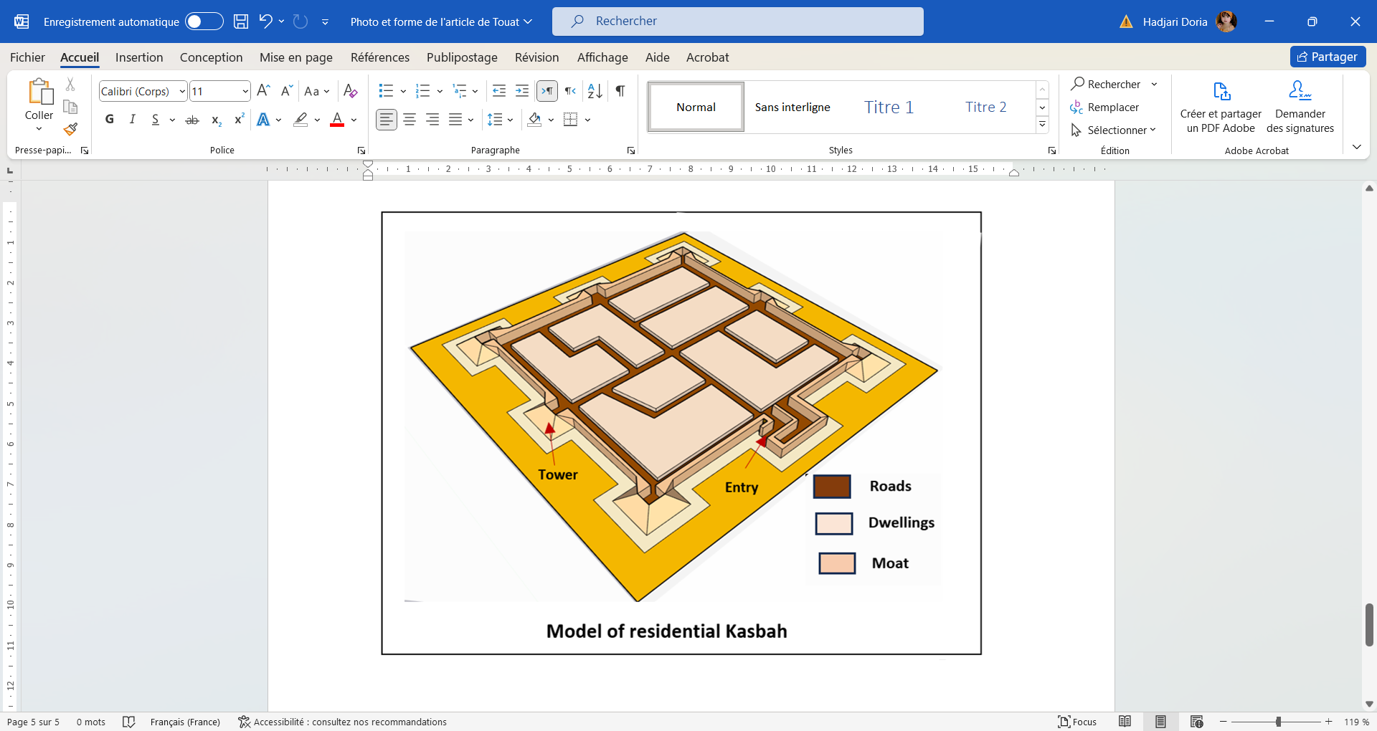

**Face n° 5: A model of residential Kasbah**

**Source : Author.**

As for Capot Rey, he categorized the kasbahs based on their function into two types: residential (royal) kasbahs and storage kasbahs, without linking them to the nature of the tribes. He also classified the types of kasbahs based on their location in relation to the Ksar, thus, we can deduce the following types:

**Kasbahs within the kasr:** Here, the kasbah overlooks the Ksar and is located in the middle of it. It is surrounded by dwellings and separated from the Ksar only by a moat and a defensive wall. An example of this is the Kasbah of Beni Mehlal that is located 4 km south of Timimoun. It is surrounded by a moat and accessed via a bridge made of palm branches. It is also surrounded by a stone wall reinforced with a tower that has loopholes. As for the interior, the largest part of this castle contains a covered passage leading to the tower, the mosque, and the well. On both sides of the passage there are multi-storey warehouses.

**Kasbahs separate from the ksar:** In this type of Kasbahs there is a large portion of palm groves or Reg that separates the kasbah from the Ksar such as the Kasbah of Qantour or Igherm Amellal (the White Kasbah) at Ksar Qantour, which is located on the western side of the Sabkha of Timimoun. This kasbah was built on a flat area and has a trapezoidal shape with a side length of about 40 meters. Its wall heights range between 5 to 6 meters, supported by five towers, each with a diameter of three meters. The kasbah has a single entrance leading to a covered passage between two storage rooms, then to an open central passageway leading to the courtyard. While, the dwellings in this type are clustered together (Rey, 1956: 144-145).

**Kasbahs without a ksar:** An example of this type is the Kasbah of Tinerkouk which is located in the northern side of Gourara and forms part of the Erg in an oasis that was previously irrigated by the *fūqāra* system. The dwellings here are scattered in the groves (two or three dwellings) and inhabited by landowners and a group of *khamasin*. Yet, they are only used in winter as in summer their inhabitants move to the *Zrayeb* (stockades), which are simple huts not far from their homes and wells.

**Kasbah and ksar in the same structure (mixed):** The most famous example of this is the Kasbah of Ajdir, where the fortified structure includes the Quranic school and the mosque; while, the residential buildings are adjacent to the storage rooms (Rey, 1956: 147).

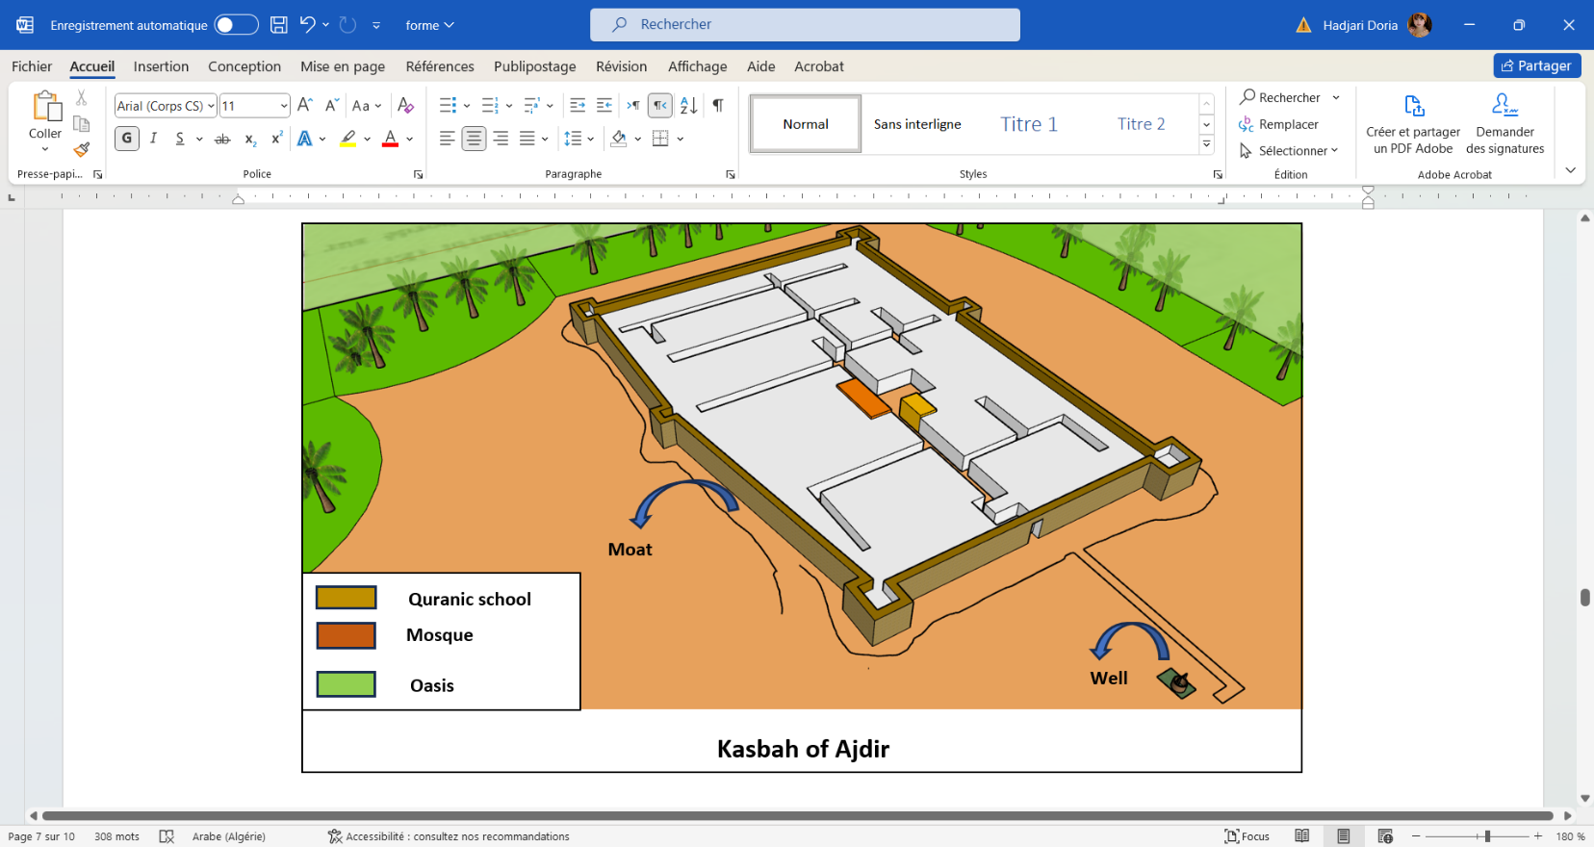

**Face n° 6: The kasbah of Ajdir**

**Source : Author.**

**Ksar without a kasbah:**

This type is very rare. In case that it existed, it would be either a zawiaya or a Ksar of the Murabitin, such as Ksar Umrad, which contains a series of individual stores that are built 100 meters away from the residential areas. These buildings have a cubic shape with a height of two meters.

Bisson adopts almost the same method with few differences. He also categorized the Ksour based on the location of the kasbah into the following:

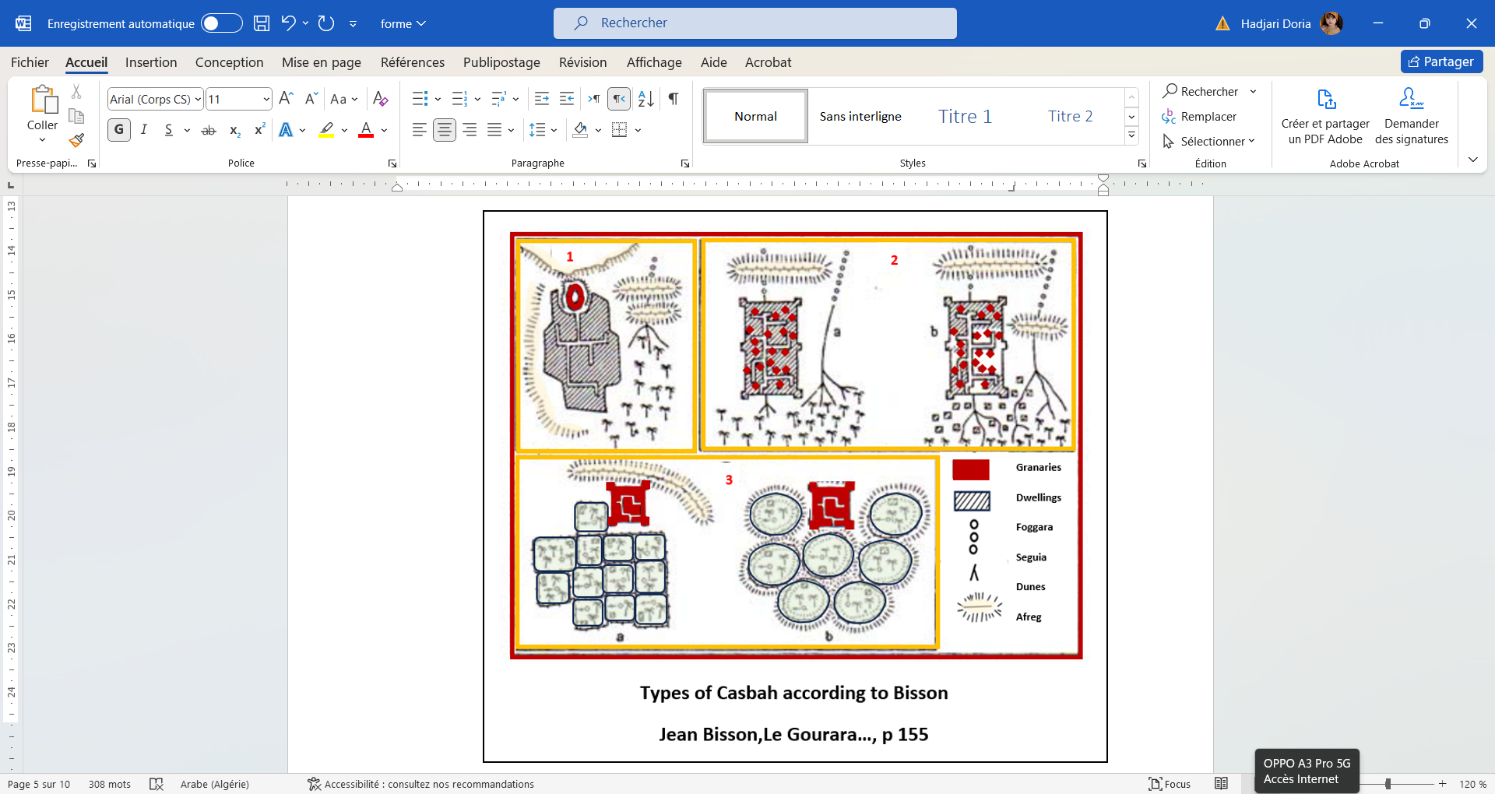

**1: Beni Mehlal Kasbah’s and ksar**

**2: Ksar without kasbah (a:Tebelkouza, b:Guellou)**

**3: Kasbahs with isolated dwelling (a:Initial plan, b: Plan in 1957)**

**Face n° 7: Types of kasbahs according to Bisson**

**Source : Jean Bisson, Le Gourara..., p 155**

**Ksour with kasbahs overlooking the ksar**: This is the most common type, where the architectural group is faced with the oasis or close to it, such as Ksour Saguiat Touat Ntebo or ksar Talmin.

**Ksour** **without kasbahs**: Bisson believes that the fortresses of this type represent Ksour rather than kasbahs. This is the same type mentioned by Capot Rey (Ksar and kasbah in the same structure) where the stores are adjacent to the dwellings. This type is common in the Sebkha (Tawriya, Azkur...) and in the Erg (such as Ajdir, Ouled ʿIssa) (Bisson, 1957: 154).

The difference between these two types is not due to ethnic reasons as Ajdir, Ouled ʿIssa, and Azkur are Berber Zanati tribes like Beni Mehlal and Lichta. It can rather be due to the population size, i.e., if the number is small, the Kasr would not need a kasbah and the stores would be adjacent to the small-sized dwellings. Whereas, when the population is dense, it is more appropriate to collect provisions.

**Kasbahs with isolated dwellings (Erg Ksour):** the examples of this type include Guellou, Tbelkouza, Naama, and Fatis. These kasbahs are charactarized by having one or sometimes two kasbahs, like those in Fatis, and their primary function is storage. They are located next to the mosque and the Quranic school, while the dwellings and stables are isolatedly distributed in the low areas surrounding the site. This isolation increases in the oases that are situated in the sandy Reg like Qalou, Naama, and Fatis. However, if the oasis is located in a non-sandy Reg, the dwellings would be clustered in groups of two to three houses. While, the dwellings of the Khamsin and owners are located in one corner of the field (like Tbalkouza and Tahentas). It is worth mentioning that this isolation is related to the use of the shadoof for irrigation (Puit à balancier), which requires a constant presence in the fields.

**Ksour of the Murabitin (Zawiyas)**: These Ksour do not contain kasbahs or defensive walls except for Kasr Sidi El-Hadj Belkacem and Badrian. An example of this type is ksar umrad, which contains about twenty storage rooms (Bisson, 1957: 155-156).

1. **Architecture of stores and methods of storage:**
   1. **The concept of stores:**

A store is an architectural structure designed for storing a tribe's reserves and providing protection during times of instability in certain types. The Gourara is the only region in the desert oases that has used storage structures similar to those found in the semi-desert mountain villages. Capot Rey emphasizes that despite the prevalence of this type of construction among various Berber tribes, the relationship between the nature of the tribes and their system of storing and saving the provisions is not due to ethnic reasons. It can rather be due to socio-economic reasons that are related to the Berber agricultural communities, such as the lifestyle and farming methods. This is in addition to security reasons that led the tribes to use them to protect themselves against theft by constructing structures fortified with walls in the form of kasbahs (Rey, 1956: 156).

* 1. **Forms and methods of storage:**

The methods of storage in the Touat territory were various. Different types were used in Gourara, Touat, and Tedikelt including the following:

* **Fortified stores**:

This type is only found in the kasbahs of the Gourara region. It is known in Berber as "*Tazerqa*," which are small cubic buildings that are barely large enough for a person to stand inside. Their dimensions are characterized by a height of 1.5 meters, a length of 4 meters, and a width of 2 meters (Bisson, 1957: 152).

They have a single entrance closed with a wooden door made of palm trunks, (Rey, 1956: 141) which contains a wooden lock or clay seal with footprints. This reminds us of the seals of the Aurasian fortresses. (See: (Faublée-Urbain, 1955) These stores do not have internal courtyards. (Rey, 1956: 143)

Dry dates are stored on a sandy layer in a high place. In some cases, such as in Taouersit, grains purchased from trade caravans are stored in the kasbah, while harvested grains are stored in the dwellings.

* **Residential stores**:

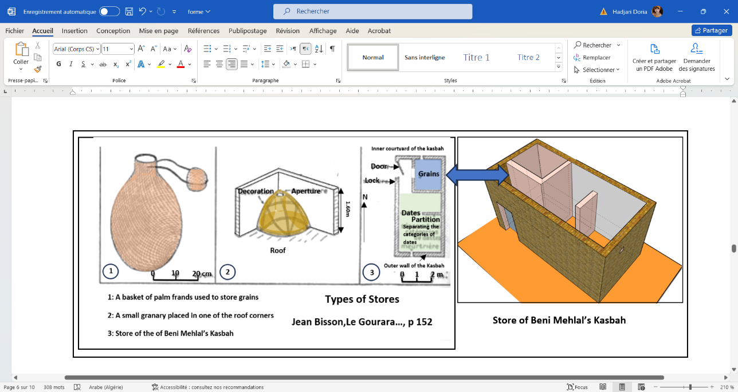Storage methods also vary within residences. In the dwellings of Touat, the storage space is found under the roof. Dates are stored on wall shelves, while, grains are stored in palm leaf baskets placed on stones to be protected from termites. Traditional baskets (*Qūfat*) and clay storage jars are also prepared in one corner of the courtyard to be used for storage. In Tedikelt, each dwelling has a roofed store space and an uncovered one (called "*Mishar*") that is used to store wheat ears before they ripen (Rey, 1956: 141-142).

**Face n° 8: Types of store**

**Source : Jean Bisson, Le Gourara..., p 152**

* **Other types of stores:**

There are other types of stores found outside the dwellings that do not resemble the kasbahs. These include **"*Aseqfar*"** storage in Tamshaq. They are represented in circular holes in the ground that are covered with flat stones constructed in a way that protects them from rainwater. However, they were later abandoned in favor of another type of stores known as **"*Takhzana*"**. These later are small buildings made of stone joined with mud mortar and have an opening at the lower part to empty the reserves. They can either be cylindrical or oval. They can also be scattered or grouped in clusters of three or four Takhzanas (Rey, 1956: 152). According to Karl Suter, they also take a cubic form with a side length of 2 meters and a height of 5 meters. Moreover, families typically owned 2 to 3 of these Takhzana-s. (Suter, 1953: 460) The square pattern is the only type used in the Touat region, while the cylindrical shape was commonly used by farmers from the Haratine tribes, who originated from the Tedikelt region. These Takhzana-s were located close to residential areas, unlike Aseqfar stores which were located far from the dwellings. These buildings are quite similar to the stores of Oumrad. They also resemble the Sudanese millet stores that are built near the residential Ksour, which may indicate the existence of trade relations between these tribes and Sudan for exchanging salt and millet. (Rey, 1956: 152-153)

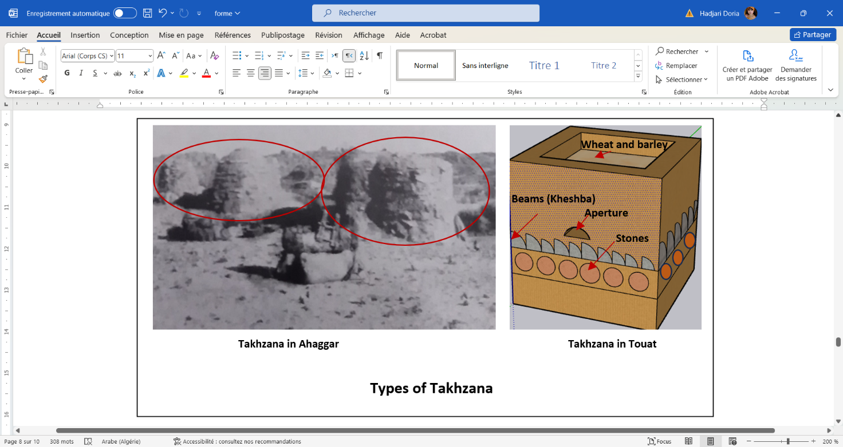

**Face n° 9: Types of Takhzana**

**Source : Capot Rey : Greniers domestiques…, plate XI**

**Conclusion:**

Based on the above, it is evident that the ksour are the fundamental unit of the desert architectural fabric. The variety of Ksour in the Touat region has prompted researchers to adopt various methods for studying their architecture and styles. Despite the significance of these studies, we can notice that the field remains open for further research to examine these Ksour in a more comprehensive and precise manner. This is in addition to considering all factors such as the distribution of its internal spaces, architectural components, architectural form, military fortifications, and tribal variations. Additionally, it is essential to study all the patterns found in the region namely in Gourara, Touat, and Tedikelt. It would be also appropriate to conduct archaeological excavations and use modern techniques to survey all the sites in the region, identify their characteristics, and determine their functions. This is especially crucial given that many Ksour are still not clearly studied such as Kasr Draa in Timimoun, which is believed to belong to the Jewish tribes. Yet, the accuracy of this information and whether it is a Ksar or a kasbah remains unclear.

Regarding the kasbahs, they appeared in most models as a pivotal part of the Ksar and sometimes independent of it or not present at all. Their role is to provide storage space, security in case of theft or warfare and sometimes they were regarded as houses for the important class of the community. As for the stores that were specifically used for storage, we noticed that most of their types were part of the kasbah. Yet, there were other types independent of the kasbahs that have taken different shapes and locations but retained the same function.

Therefore, the relationship between the Ksar, kasbah, and store is represented in the functional and architectural integration that ensures security and social and economic stability for the Touat community. This appears in the fact that the ksar represents the social and defensive center; while, the kasbah provides protection and storage and the store ensures economic sustainability by storing essential resources. Consequently, each element enhances the function of the other in a cohesive system that reflects the traditions and heritage of the region.

**Bibliography:**

**Sources:**

1. Abū Alqāsim Ibn Hawqal. (1938). *Ṣūrat al arḍ*. Leiden: Printing to Prill.
2. ʿabd Arrahmān Ibn Khaldūn, *Tārīkh Ibn Khaldūn Al ʿibar wa dīwān lmūbtadaʿ wa lkhabar fi ayāmi lʿarab wa lʿajam wa lbarbar wa men ʿāsarahūm min dhawī sūltān alʾa kbar*. Tome 6, cairo :Būlāk Press.
3. Ibn Battūta, Manuscripted by ʿabd lhadi attāzī.(1997) .*Tūhfāt annāẓār fi gharāʿib al amṣār wa ʿajāʿib al asfār*,Tome 01(Chapter of back to the Maghreb).Rabat.
4. Mārmol Kārbākhāl, Translated by Mūhamed hejī and others. (1984). *Ifrīqyā*. Tome 3, Rabat: Al maʿārif al jadīda Press.

**Books:**

1. Bisson, Jean. (1957). *Le Gourara (Etude de géographie humaine).* Alger: Institut des recherches sahariennes, Université d’Alger.
2. Echallier(Jean Claude). (1972). *Villages désertés et structures agraires anciennes du Touat-Gourara (Sahara Algérien).* Paris: Achevé d’imprimer sur presse de la S.R.I.P.
3. Faraj, Mahmūd Faraj. (1977). *Iqlīm tūat khilāl lqarnayn athamin ʿashar wa atāsiʿ ʿashar -dirāset li ʾawḍāʿ alʾiqlīm ʾassiyāsiya wa lʾijtimaʿiya wa lʾiqtisādiya wa thqafiya-* (Touat region during the eighteenth and nineteenth centuries -a study of the political, social, economic and cultural conditions of the region-. Algeria : Printed by Dīwān el matbūʿāt ljamiʿiya.
4. Martin, Alfred Paul. (1908). *Les oasis sahariennes (Gourara-Touat-Tedikelt).* Paris: A. Challamel.
5. Terrasse, Henri. (1938). *Kasbas berbères de l’Atlas des Oasis (Les grandes architectures du sud Marocain).* Paris: Edition des horizons de France.

**Articles:**

1. Antonio Malfante, & Mercante Genovese. (1868). « *Prima met adel secolo XV e viaggiatore nell’interno del continente africano, nota del socio »,* *Bollettino Della Società Geografica Italiana,* anno 1, fascicolo 1, Firenze 1868, pp 441-456.
2. Faublée-Urbain, Marcelle. (1955). *« Sceaux de magasins collectifs (Aurès) ». Journal de la Société des Africanistes,* Tome25, pp 19-23.
3. Meunié, Jacques. (1951). « *Grenier-Citadelles au Maroc », Arts et métiers graphiques*, Tome2.
4. Rey, Capot. (1956). « *Greniers domestiques et greniers fortifiés au Sahara (Le cas du Gourara) ». Travaux de l’institut des recherches sahariennes.* Tome XIV, 1 et 2émé semestre, pp139-157.
5. Suter, Karl. (1953). « *Etude sur la population et l’habitat d’une région du Sahara Algérien (Le Touat) ». Revue de géographie Alpine*. Tome 21, 3, pp 443-474.
6. Voguet, Élise. (2018). *« Le peuplement du Touat au xive-xvie siècle: mémoire locale de lignages au sein d’un espace socioculturel connecté ».Une histoire sociale et culturelle du politique en Algérie*. Paris: Éditions de la Sorbonne. pp39-55.